March 23, 2018

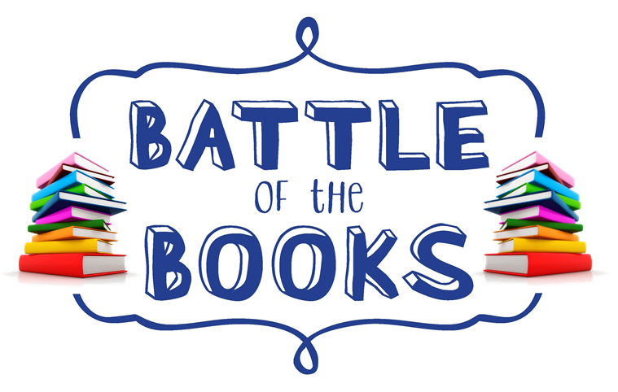

**Dear Parents of 4th and 5th grade students,**

McLeansville Elementary is proud to be able to offer the Elementary Battle of the Books (BOB) program which is open to fourth and fifth grade students. The aim of the program is to expose students to quality literature from a variety of genres. This team is optional! All team members must maintain an A/B average and cannot have behavior referrals to remain on the team and compete in the BOB Competition.

The BOB program was designed and is overseen by the North Carolina School Library Media Association and is responsible for choosing the fifteen books that will be read and discussed. Each Monday from 2:30pm-3:30pm, starting in September of next school year (2018-2019) our Battle of the Books team will meet in the media center to discuss the assigned books and participate in activities aimed at deepening the level of understanding of each book.

In January of 2019, twelve students will be chosen (based on points earned) to represent our school at the district competition to be held in March.  After the 12 members have been chosen only the 12 team members will attend the weekly meetings. The competition is a ‘quiz bowl’ style event in which teams from participating elementary schools work together to answer questions about the books on the list. The school team with the most points wins the competition.

Summer is the perfect time to start reading the list of books chosen for the competition. **More detailed information will be shared with the students who return the attached interest form**.

If you have any questions, please do not hesitate to reach out to Mrs. Glover or Mrs. Kelley.

**BOB** **Coaches**:

**Marie Glover**- Library Teacher/Media Specialist

[gloverm@gcsnc.com](mailto:gloverm@gcsnc.com)

**Cherlyn Kelley**- Curriculum Facilitator

kelleyc@gcsnc.com

**\*\*\*RETURN THE BOTTOM HALF OF THIS SHEET IF INTERESTED\*\*\***

Today all 3rd grade and 4th grade students came to the Media Center for a presentation about the Battle of the Books (BOB) Team at McLeansville Elementary School.

Mrs. Glover and Mrs. Kelley explained to the students what “Battle of the Books” is and the requirements for being on the team. The team members for the current school year performed a “Mock” Battle to show students what the BOB Competition is like.

If your child is interested in being on the MES Battle of the Books team for the 2018-2019 school year, fill out the bottom portion of this sheet and RETURN to Mrs. Glover as soon as possible.

Check out more info about BOB and see some photos on our school website under the MEDIA CENTER tab:

**www.gcsnc.com/mcleansville_elementary**

--------------------------------------------------------------------------------------------------***\*\*\* RETURN THIS FORM TO MRS. GLOVER\*\*\****

***… ONLY if you are interested in joining the Battle of the Books Team for the 2018-2019 school year.***

**Student Name: _____________________________________**

**Parent Name: ______________________________________**

**Parent Signature: ___________________________________**

**Parent Email: _______________________________________**

**this will be used to create a distribution list for BOB parents to receive updates and information about the program

NC Elementary Battle of the Books List

2018-19

|  |  |
| --- | --- |
| Title | Author |
| *At the Bottom of the World | Bill Nye & Gregory Mone |
| Ban This Book | Alan Gratz |
| Becoming Naomi Leόn | Pam Muñoz Ryan |
| Blood on the River | Elisa Carbone |
| **Found | Margaret Peterson Haddix |
| The Fourteenth Goldfish | Jennifer L. Holm |
| How to Steal a Dog | Barbara O'Connor |
| The Old Willis Place | Mary Downing Hahn |
| Rain Reign | Ann M. Martin |
| Ruby Holler | Sharon Creech |
| Runaway Twin | Peg Kehret |
| Save Me a Seat | Sarah Weeks & Gita Varadarajan |
| A Snicker of Magic | Natalie Lloyd |
| Stella by Starlight | Sharon M. Draper |
| A Wrinkle in Time | Madeleine L’Engle |

*Jack and the Geniuses - Book 1

**The Missing Series - Book 1